2013-UA-01-3.odt Colourful Table

0 ---- | I: ----- | II: medium | III: easy | IV: ----

Answer Type: Multiple Choice (may be interactive)

Body

A little beaver would like to pave his new room with different coloured tiles:
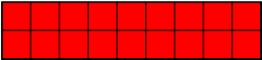
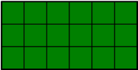
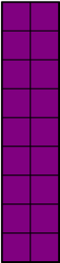
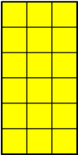
He decided that he will not rotate or cut the tiles in any way.
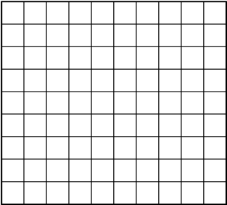

He wants to make his room as colorful as possible.

Question

What is the most number of different colours he can use ?
- 1
- 2
- 3
- 4

Answer

c) 3

Explanation
It is impossible to pave red tile of width 9, because there is no tile with the width of 1. We can use all the other tiles.
For example:
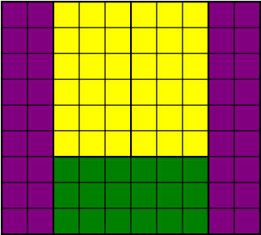

It's informatics

The partition on the subsets of given sizes is one of the classical problems in the Algorithms theory.
It is packing problem, where we have an area and we decide how to cover the area with certain shapes.

Keywords

Partition, graphical algorithm

Websites

Internal Use

Wording

Comments
Christian Datzko, Switzerland, christian.datzko@edubs.ch: the same comments as for 2013-UA-01-1 apply, see ../2013-UA-01-1/2014-UA-01-review.ods.

Špela Cerar, 2014-06-03: Could be interactive, changed wording
Peter Garscha, Austria, peter@rlsux.com, 2014-06-03: svg-graphics missing, it's informatics need more explanation.

Ahto Truu, ahto.truu@ut.ee (2014-09-25): regenerated all graphics in SVN and PNG.

Files

2013-UA-01-3.odt (this file)
floor9x10.png
floor9x10.svg
tile2x9red.png
tile2x9red.svg
tile3x6green.png
tile3x6green.svg
tile6x3yellow.png
tile6x3yellow.svg
tile9x2purple.png
tile9x2purple.svg
floor9x10answer.png
floor9x10answer.svg

Authorship

author: Maria Hasanova, osvitarda@rambler.ru
translating: Lesia Ilishchuk, ilishchuk@i.ua
review: Špela and Maciej

License

Copyright ©2013 Bebras - International Contest on Informatics and Computer Fluency.
This work is licensed under Creative Commons Attribution-NonCommercial-ShareAlike 3.0 Unported (CC BY-NC-SA 3.0).
Visit: http://creativecommons.org/licenses/by-nc-sa/3.0/

